**Lambda Expression Assignment**

**1. Write an application to perform basic arithmetic operations like add, subtract, multiply & divide. You need to define a functional interface first.**

**Description:-**

Define Functional Interface and write a program to perform arithmetic operations like add, subtract, multiply and divide using functional interface.

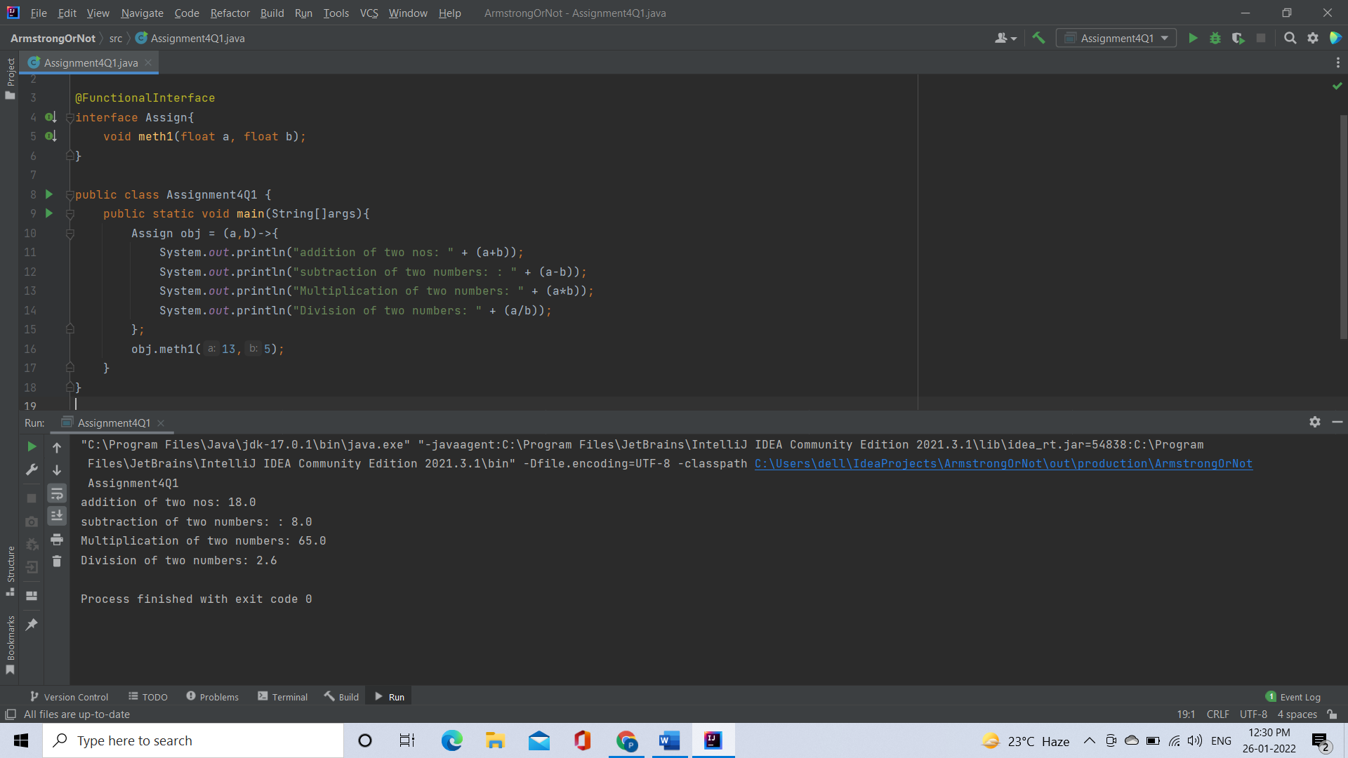

[**2**](https://adapt.in.capgemini.com/mod/vpl/view.php?id=2156)**. Write an application using lambda expressions to print Orders having 2 criteria implemented: 1) order price more than 10000 2) order status is ACCEPTED or COMPLETED.**

**Description:**

Write a program in such a way that it has a method which returns the list of orders satisfying the 2 conditions mentioned in the question

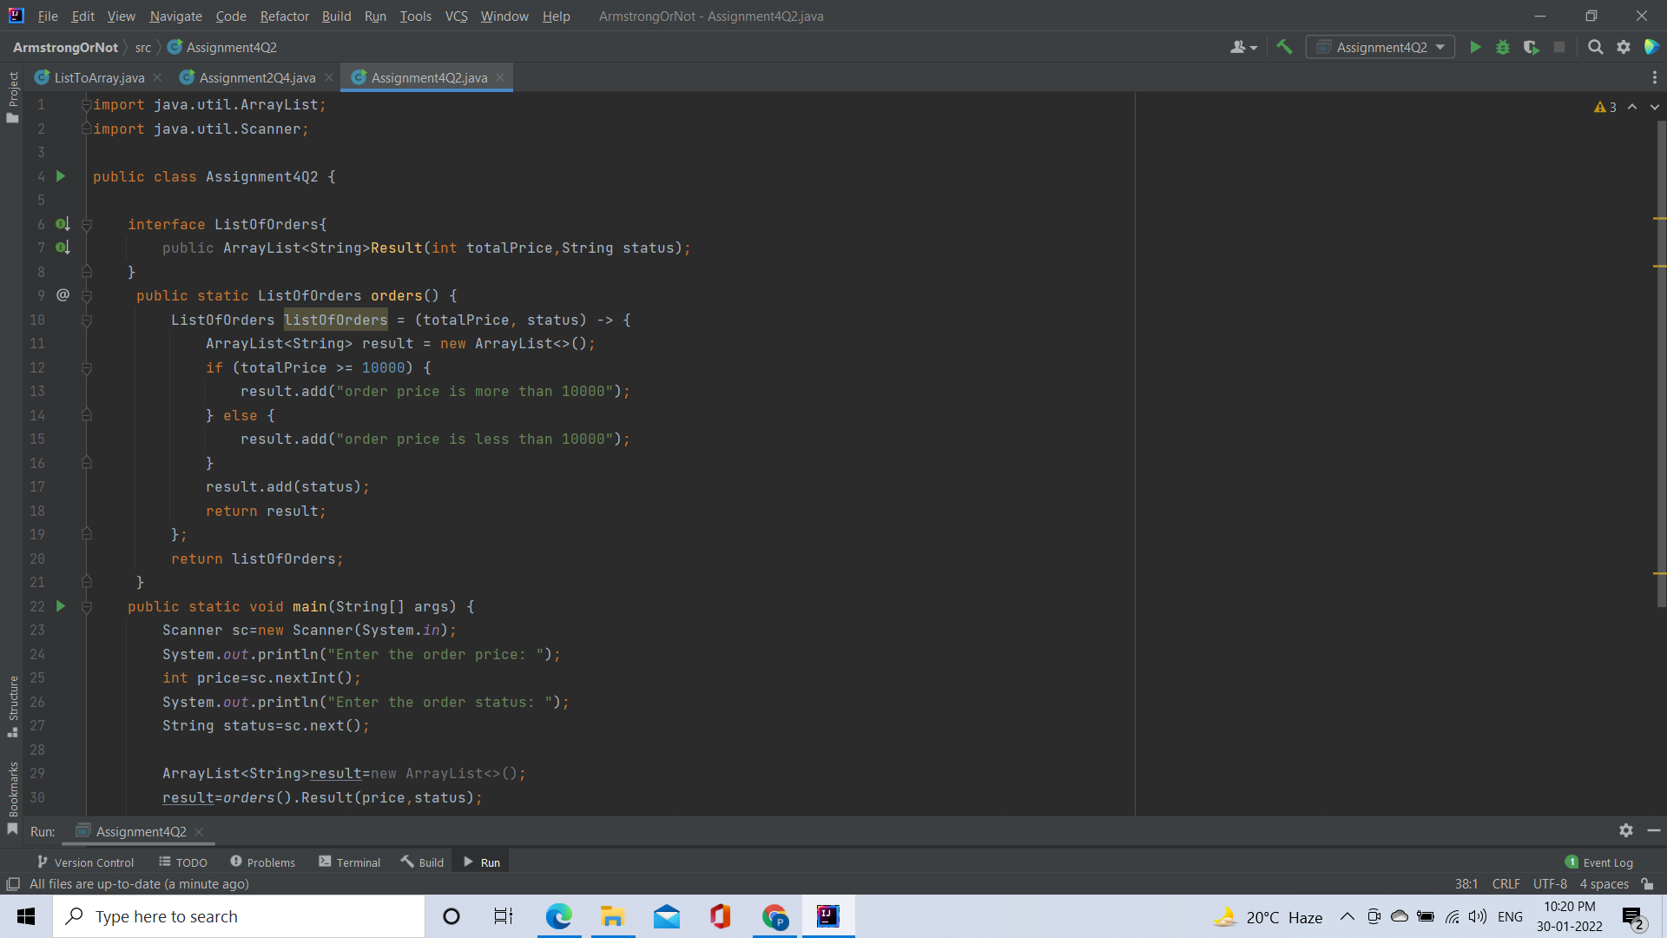

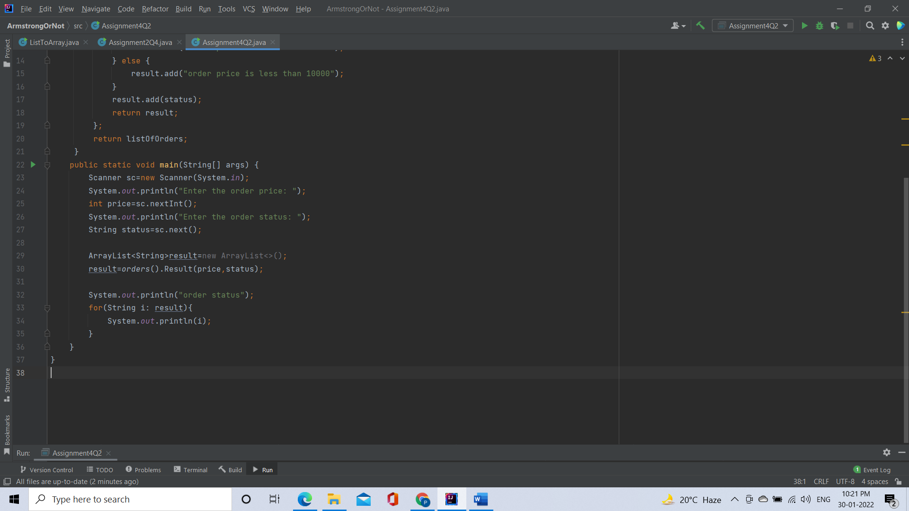

Output:

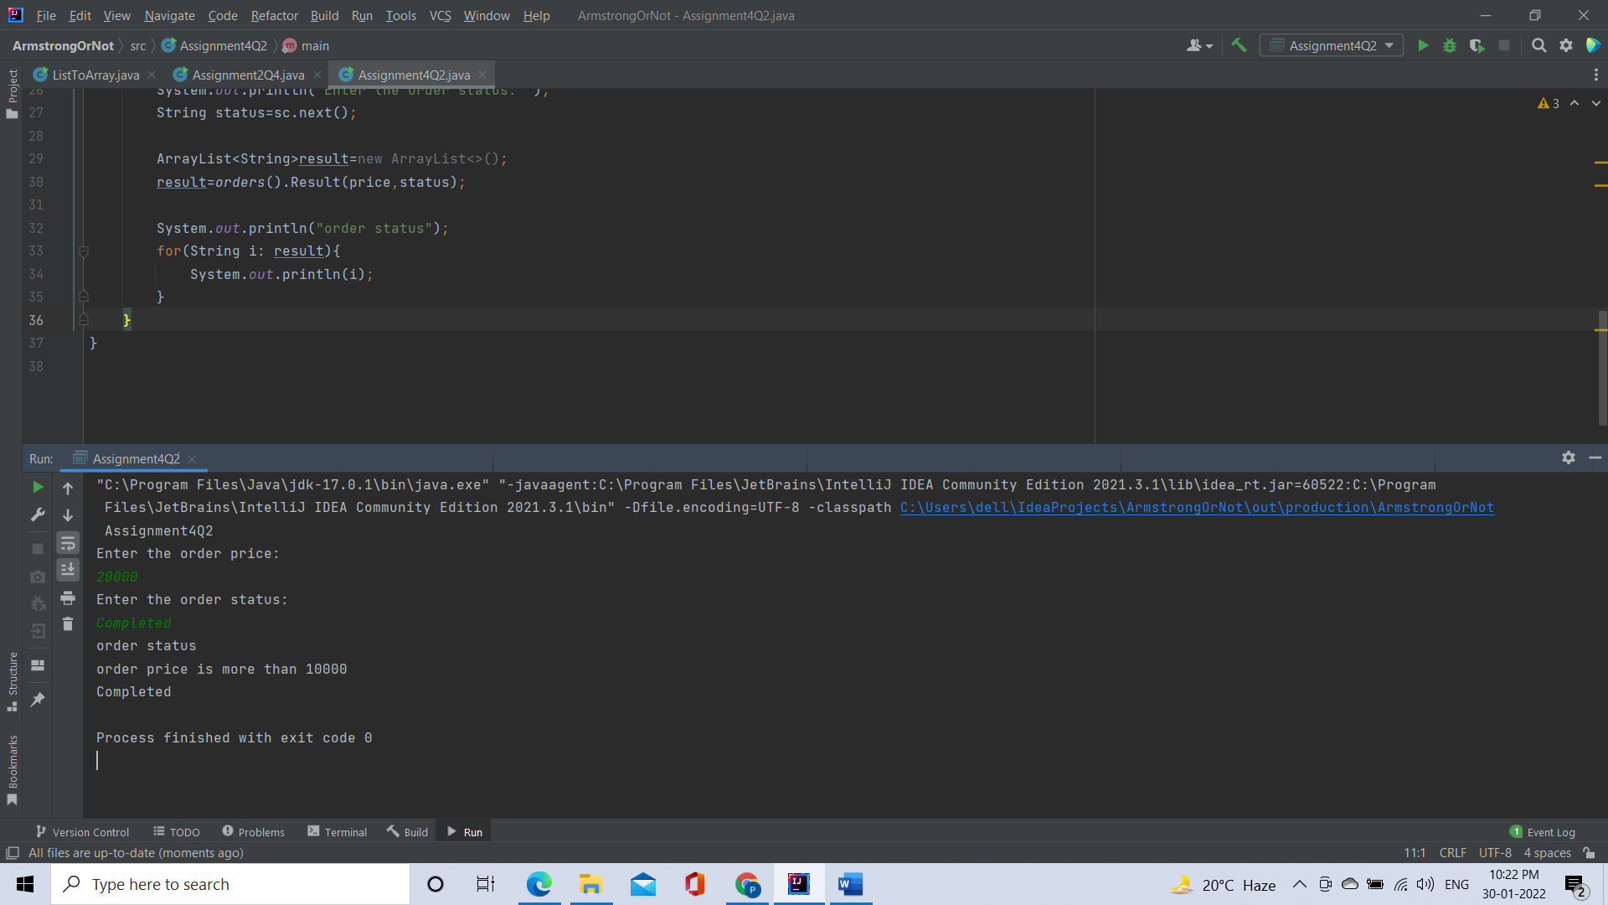

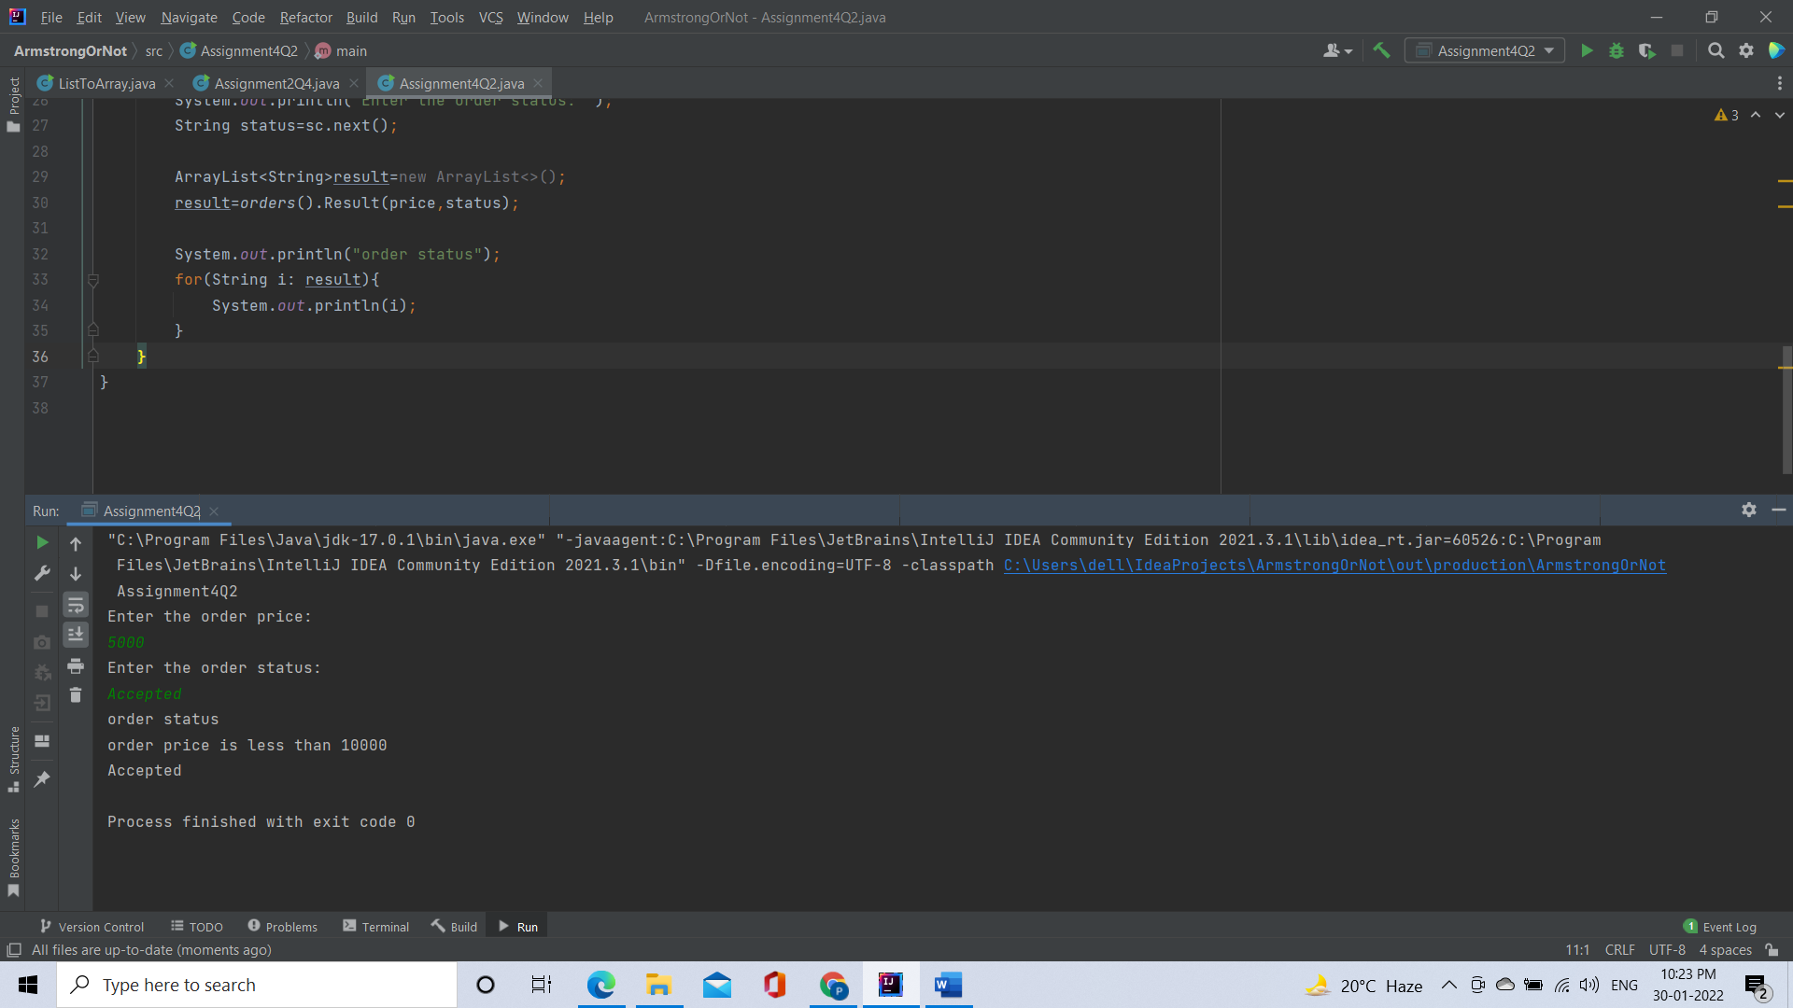

[**Q4**](https://adapt.in.capgemini.com/mod/vpl/view.php?id=2262)**. Remove the words that have odd lengths from the list. HINT: Use one of the new methods from JDK 8. Use removeIf() method from Collection interface.**

**Description:-**

Write a program using java 8 features which can remove the odd length words from the list.

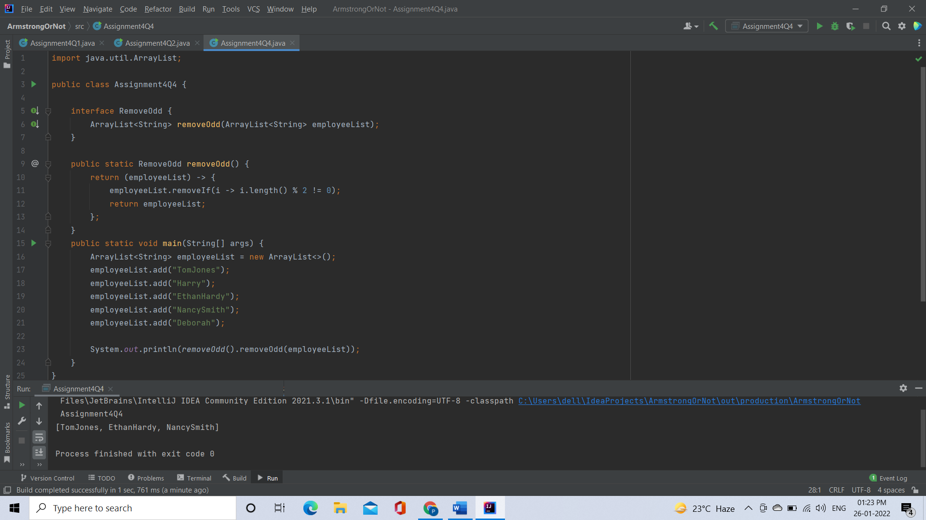

[**Q5**](https://adapt.in.capgemini.com/mod/vpl/view.php?id=2153)**. Create a string that consists of the first letter of each word in the list of Strings provided. HINT: Use Consumer interface & a String Builder to construct the result.**

**Description:**

Write a java program using StringBuilder and Consumer interface which will return a string. The returned string should consistes of the first let of each word in the list of words

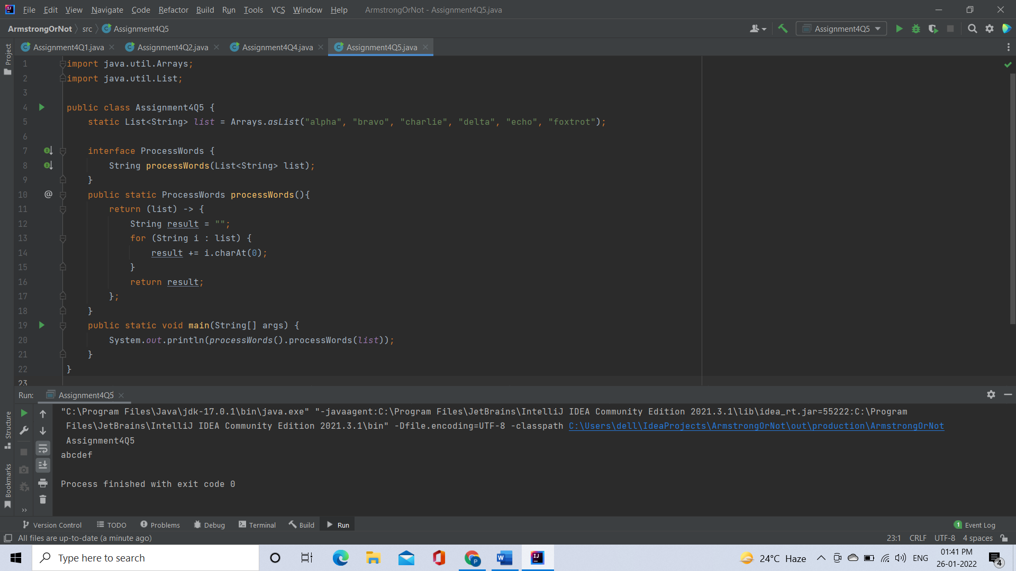

[**Q6**](https://adapt.in.capgemini.com/mod/vpl/view.php?id=2145)**. Replace every word in the list with its upper case equivalent. Use replaceAll() method & Unary Operator interface.**

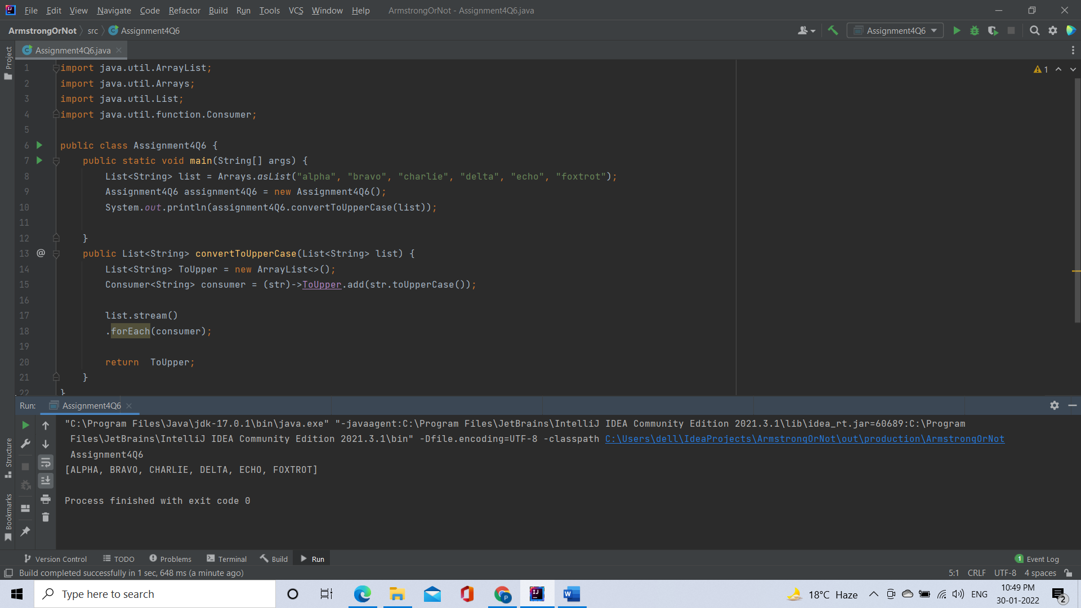

[**Q7**](https://adapt.in.capgemini.com/mod/vpl/view.php?id=2146)**. Convert every key-value pair of the map into a string and append them all into a single string, in iteration order. HINT: Use Map.entrySet() method & a StringBuilder to construct the result String**

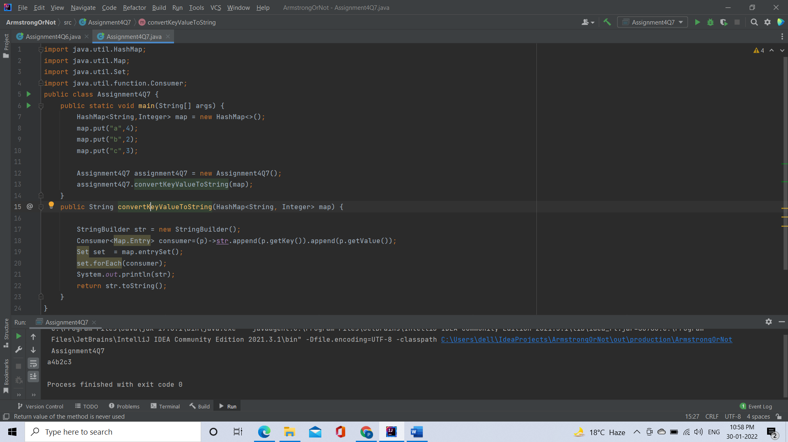

[**Q8**](https://adapt.in.capgemini.com/mod/vpl/view.php?id=2147)**. Create a new thread that prints the numbers from the list. Use class Thread & interface Consumer.**

**Description:-**

Write a java program which will print the list of number using Thread and interface Consumer

